**Extracting DNA from Banana** **Tissues**   
 *Noor Ali, Noor Zaid  
 Teachers: Ahmed I.*, Mohammed J,*

**G10-AG**  
 Maarif Schools – Mansour - Baghdad

In this study, we have been able to concentrate and extract DNA from Banana tissue (scientific name ‘Musa acuminata’) using commonly available items.  
The study was done using the following tools:

1. A weighing scale (<1g accuracy)
2. Ziplock plastic bags and mesh filters
3. Disposable measuring cups
4. 1L beakers and cutting knife
5. 2000+ RPM centrifuge

The used ingredients are listed and shown in figure below:

1. Cold 200 mL Ethyl alcohol (95%+)
2. 20 mL Liquid dish soap
3. 180 mL Distilled water
4. 250*g* Banana (Musa acuminata)
5. 4*g* Table salt

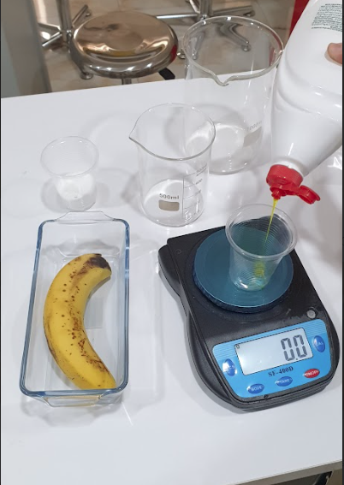

Figure - The ingredients and tools used to extract DNA

**Procedure:** First, the banana was peeled and sliced, additionally, a solution of 180 mL water and 20 mL of dish soap, and 4 g of salt, all mixed in a 1L beaker. The solution is mixed and the dish soap will act as a surfactant for the DNA extraction.

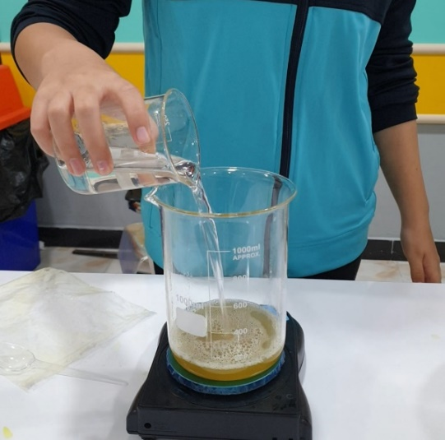

Figure 2 The solution is prepared using Table salt, distilled water,  
 and dish soap

Next, the sliced banana sample *Musa acuminata* is sliced at into thin slices with the purpose of maximizing the contact area with the prepared solution

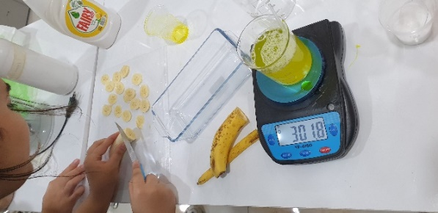

Figure The sample being cut into slices as preparation for mixing in the solution

The slices are then placed in a Ziplock bag with the previously mixed solution added to it and mixed thoroughly, so that the salty soap water solution breaks down cell membranes and release the DNA. The soap dissolves the lipids in the cell and nuclear membranes, while the salt helps to neutralize the negatively charged DNA molecules, making them less soluble in water and easier to precipitate. This process enables the DNA to clump together and be more easily collected

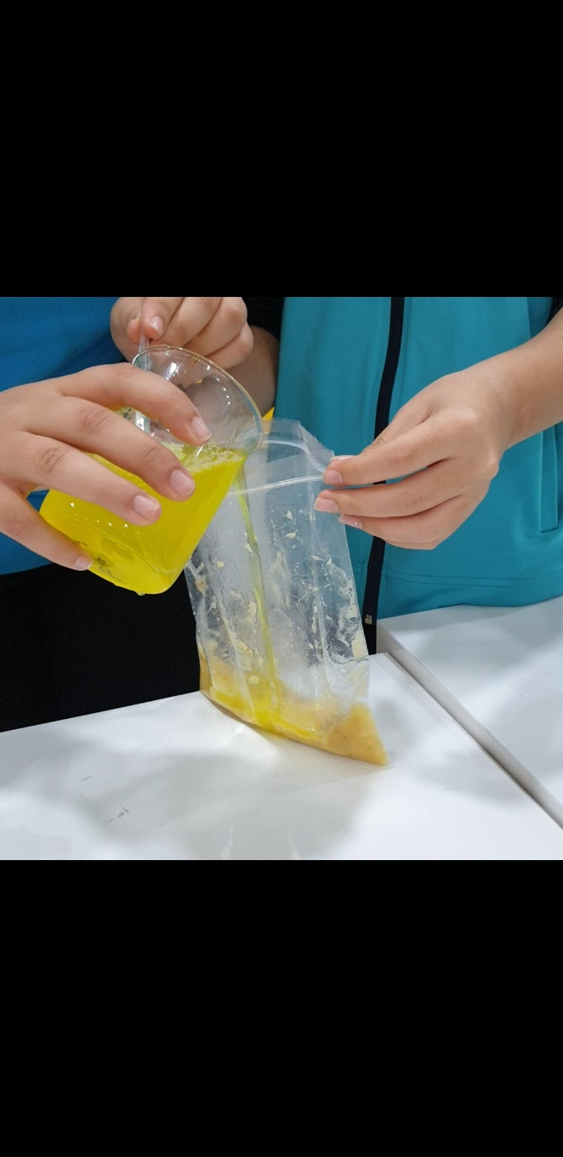

Figure The soapy salt solution is added to the sliced fruit

The solution is thoroughly shaken and mixed for two minutes to allow maximum reaction time. Next, the DNA will be dissolved in liquid solution, it is then filtered using a coarse mesh filter to separate it from fibers

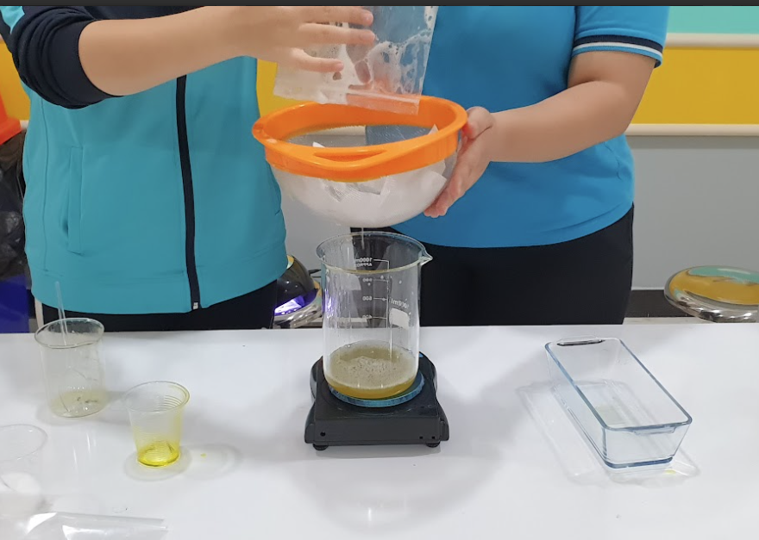

Figure The filtrate of the solution containing DNA

Finally, it is important to add ice cold ethyl-alcohol with 90%+ purity in order to allow the DNA to precipitate as it is soluble in water but not in ice cold alcohol, being cold, the ethanol will form a layer on top of the water for it to precipitate, finally, due to low temperature, ice cold alcohol will potentially slow down the breakdown of the DNA. In our study, we found it useful to centrifuge the solution in pipettes to extract the DNA molecules, this has proven effective by centrifuging at 2000 RPM for 1 minute, the solution separated the remaining DNA from the liquid mixture.

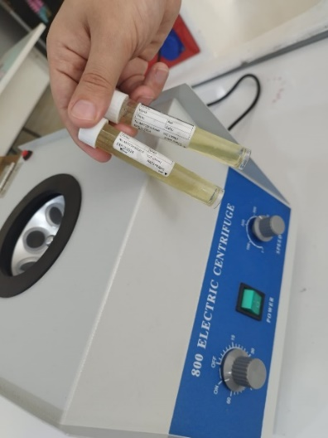

Figure Centrifuged DNA separated on top of solution

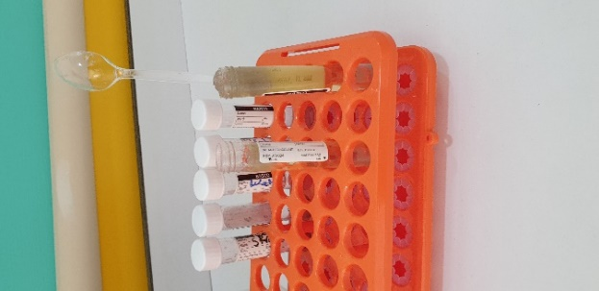 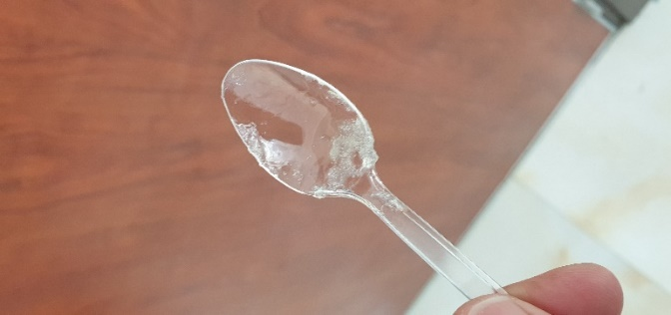

Figure extracted DNA

We conclude that this method is sufficient to extract DNA from *Musa acuminata tissues* with common materials.

The extracted DNA has a viscous texture to it and has a relatively low density, this study paves the way for future studies where it could be useful to know how DNA is directly affected by chemicals (phenols, etc..) or by physical effects (UV, x-rays, …)